**Assignment #02**

* **Covert Temperature from Fahrenheit to Celsius & Celsius to Fahrenheit as well. °F = (Temperature in Celsius (°C) * 9/5) + 32 .°C = (Temperature in Fahrenheit (°F) - 32) * 5/9**

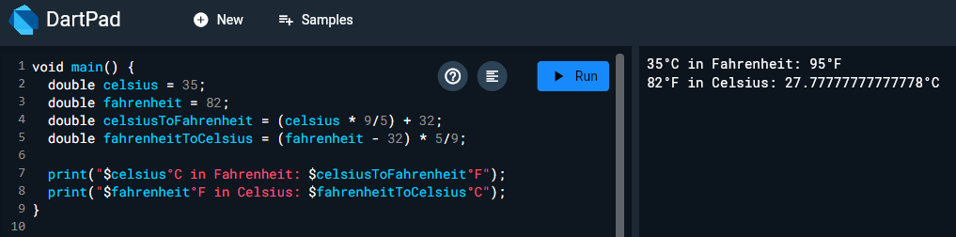

* **Length and breadth of a rectangle are 5 and 7 respectively. Write a program to calculate the area of the rectangle. Formula (area = length * breadth)**

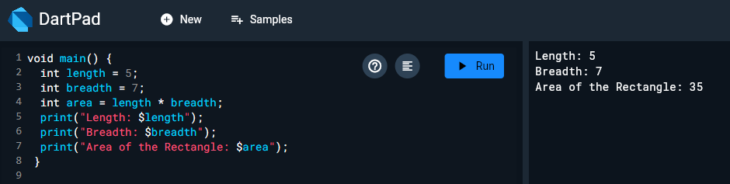

* **Create a integer variable num = 7, Add 8 to the number and then divide it by 3. Now, the modulus of that number is taken with 5 and then multiply the resultant value by 5, store result in variable i. Display the final result.**

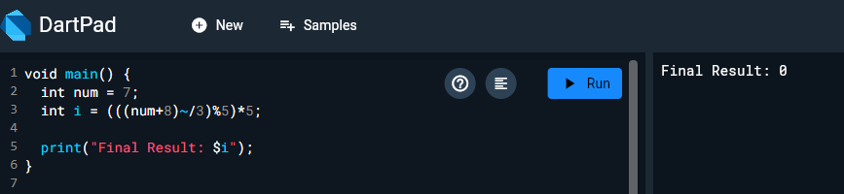

* **If the marks of Robert in three subjects are 78,45 and 62 respectively (each out of 100 ), write a program to calculate his total marks and percentage marks. Print his name, marks of all three subjects, total marks and percentage.**

